Pandit Deendayal Energy University, Gandhinagar School of Technology
Department of Computer Science & Engineering


Introduction to Web Technology (23CP306P)

Name: Ravi Jamanbhai Makwana
Enrolment No: 21BCP418
Semester: 5
Division: 6
Group: 12
Branch: Computer Science

Practical 3

Aim: Install the LAMP stack

Hardware Requirement: Computer: HP Laptop

Software Requirement:

  - 1. Operating System: XAMPP is compatible with Windows, macOS, and Linux. Ensure your system meets the following OS-specific requirements: Windows: XP, Vista, 7, 8, 10
  - macOS: 10.6 or later
  - Linux: Any modern distribution with a 32- or 64-bit architecture.

- Web Browser: You will need a web browser for testing your web applications. Popular choices include Google Chrome, Mozilla Firefox, and Microsoft Edge.

- XAMPP Software: Download and install the XAMPP software from the official website (https://www.apachefriends.org/). Make sure to download the version that matches your operating system.

- Text Editor or IDE: A text editor or integrated development environment (IDE) for writing and editing your web application code. Popular options include Visual Studio Code, Sublime Text, and PHP Storm.

- Database Management Tool: If your web application uses databases, you may need a database management tool such as phpMyAdmin (included in XAMPP) or MySQL Workbench.

Knowledge Requirement:

- Fundamental grasp of web technologies, which include HTML, CSS, JavaScript, and PHP.
- Familiarity with web servers, databases, and server-side scripting.
- Understanding of your operating system (whether it's Windows, macOS, or Linux) and its command-line interface.
- Awareness of best practices for ensuring security while configuring and using web servers.

Theory:
The LAMP stack is a popular open-source software stack commonly used for web development and hosting. LAMP is an acronym that stands for:

1. Linux: The "L" in LAMP refers to the Linux operating system, which serves as the foundation of the stack. Linux is an open-source, Unix-like operating system that provides a stable and secure environment for web servers. It is known for its scalability, versatility, and robust security features.

2. Apache: The "A" represents the Apache HTTP Server. Apache is a widely used, opensource web server software that is renowned for its reliability and performance. It serves as the web server component of the LAMP stack, handling HTTP requests and delivering web content to clients. Apache is highly customizable and supports a range of features, including URL rewriting, authentication, and SSL encryption.

3. MySQL: The "M" stands for MySQL, a popular open-source relational database management system (RDBMS). MySQL is known for its speed, scalability, and ease of use. It is used to store, manage, and retrieve data for web applications. MySQL is compatible with various programming languages and can be integrated seamlessly into web applications to provide dynamic data storage and retrieval.

4. PHP: The "P" signifies PHP, which is a widely used open-source server-side scripting language. PHP (Hypertext Preprocessor) is embedded within web pages and executed on the web server. It allows developers to create dynamic and interactive web applications by generating content on the server before sending it to the client's web browser. PHP can interact with databases, handle forms, and perform a wide range of server-side tasks. In summary, the LAMP stack is a robust, open-source solution for web development and hosting. It combines the Linux operating system, the Apache web server, the MySQL database, and the PHP scripting language to create a versatile, scalable, and cost-effective environment for building and deploying web applications. Its popularity in the web development community is a testament to its reliability and adaptability.

Steps and Output:

- Install XAMPP

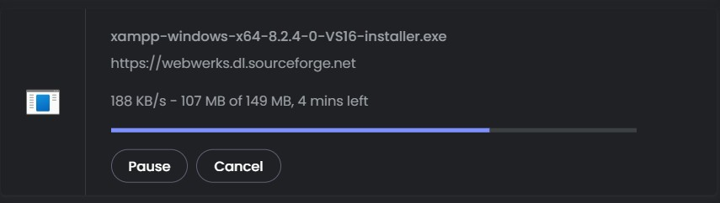

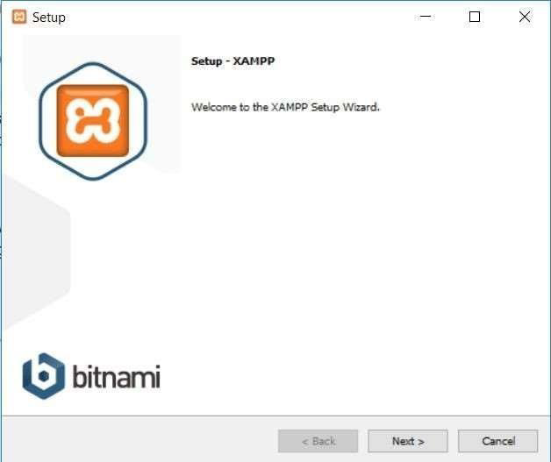

Just click Next to continue.
On the next screen, you can choose which components to install. To install XAMPP and WordPress, you do not need all the components. In addition to the required components, all you need are:
- MySQL
- phpMyAdmin

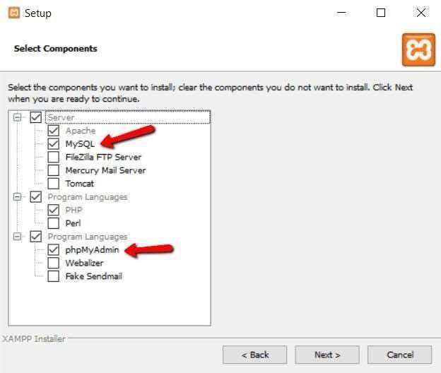

Again, this is all that is needed to install WordPress locally. Uncheck everything else and click Next.
You can now select which folder to install XAMPP in. I always leave it as the default:

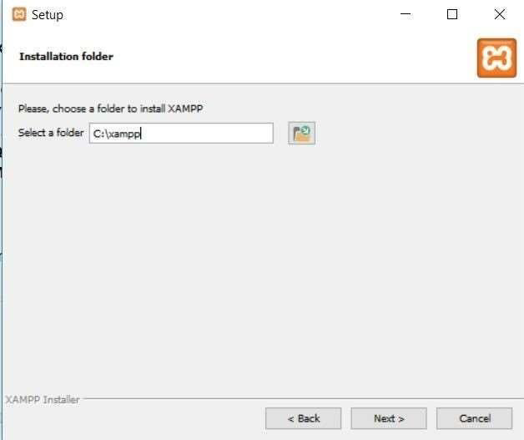

On the next screen, you’ll get a prompt asking you to install Bitnami for XAMPP. You do not need this to install XAMPP and WordPress, so just uncheck the box:
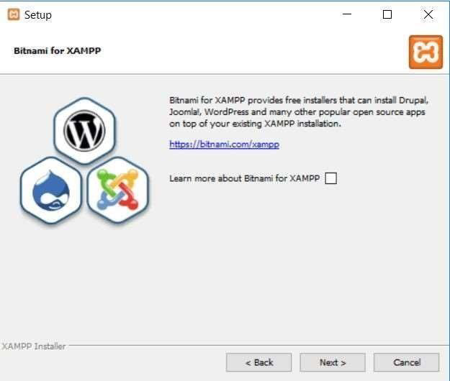

Once you click Next, you are ready to run the install:
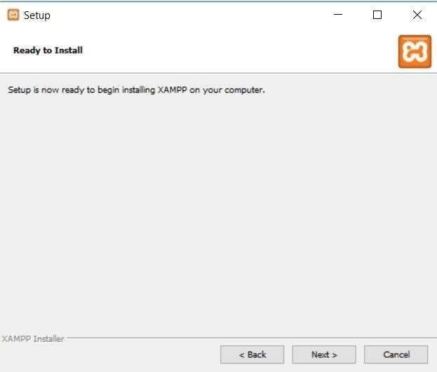

The install process might take a few minutes:

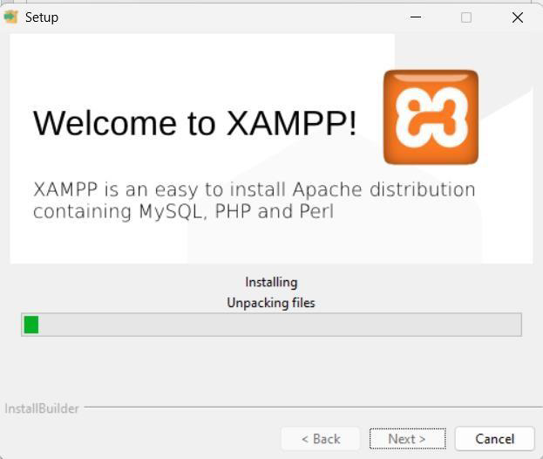

Once it finishes, you can launch the control panel to start working with XAMPP:

2. XAMPP Control Panel (Starting Apache and MySQL)
To install XAMPP and WordPress properly, you’ll need to run two modules:
- Apache
- MySQL

You can start both modules from the XAMPP control panel:

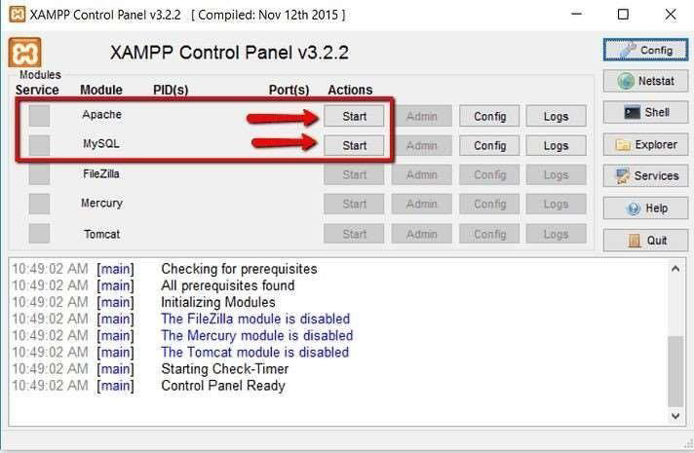

Once you launch them, you should see their status turn to green:

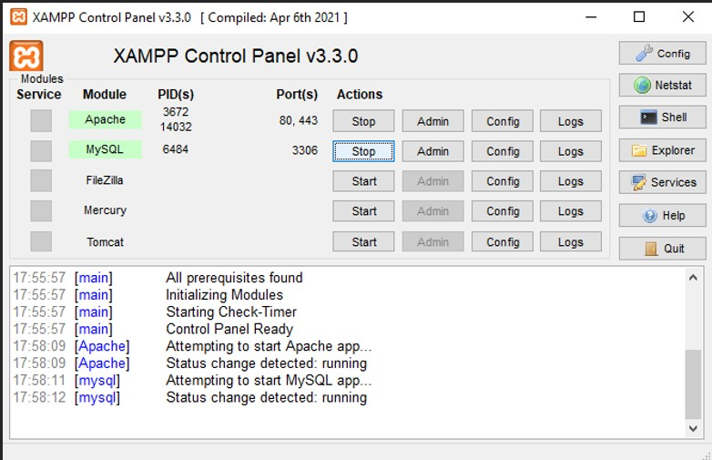

And now you should be able to test that your local server is working by going to http://localhost/ in your web browser of choice:

Conclusion:
The setup of the XAMPP stack, incorporating Apache, MySQL, PHP, and Perl, offers a simple and user-friendly method for swiftly establishing a local web server environment. It presents a convenient foundation for web development, testing, and hosting web applications. With XAMPP installed, users obtain access to vital web server elements and can easily oversee databases, execute server-side scripts, and craft dynamic websites. In summary, XAMPP streamlines the process of establishing a local development environment and is an invaluable asset for web developers, making it an excellent choice for those seeking to create and test web applications without the intricacies of configuring each server component individually.

References:
https://www.apachefriends.org/download_success.html

